
Department of BES-1
DATA STRUCTURES USING PYTHON
I-B.Tech-(II Sem), Academic Year: 2024-2025

Session 02 Algorithm Analysis:

Aim of the Session:

To familiarize students with algorithmic analysis to evaluate time complexities.

Objectives
This Session is designed to:
- Analyse the algorithm to run time complexity.
- Analyze the time and space complexities of algorithms

Learning Outcomes

At the end of this session, you should be able to:

Evaluate the time complexities of the different Algorithmic solutions for various types of Problems.

Write the notations for calculating the running time complexity of different algorithms

Session Introduction
In this session we will discuss about
  - Basic definition of the Algorithm and Data structure
  - Definition of complexity of an Algorithm
  - Example of Time Complexity
  - Various Notations to find the performance of the algorithm
- ALGORITHM ANALYSIS:
ASYMPTOTIC NOTATIONS:
- The performance of an algorithm can change with a change in the input size
- Asymptotic Notations can describe an algorithm's run time when the input tends toward a specific or limiting value.
- Asymptotic analysis helps to analyze the algorithm performance change in the order of input size.
- Usually, the analysis of an algorithm used for calculating the running time complexity of an
algorithm is done based on three Asymptotic Notations:
    - Best Case (Omega Notation (Ω))
    - Average Case (Theta Notation (Θ))
    - Worst Case (Big-O Notation(O))
OMEGA NOTATION (Ω):
- It is the formal way to represent the lower bound of an algorithm's running time.
- It measures the best amount of time an algorithm can take to complete or the best-case time complexity.
Mathematical Representation of Omega notation:
Omega (Ω) notation specifies the asymptotic lower bound for a function f(n). For a given function g(n), Ω(g(n)) is denoted by:
Ω (g(n)) = {f(n): there exist positive constants c and n0 such that 0 ≤ c*g(n) ≤ f(n) for all n ≥ n0}.
This means that, f(n) = Ω(g(n)), If there are positive constants n0 and c such that, to the right of n0 the f(n) always lies on or above c*g(n).
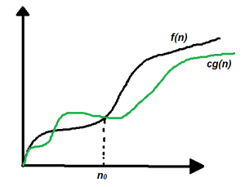
Fig 3: Graphical representation of Omega Notation Example
THETA NOTATION (Θ):
- Every time, an algorithm does not perform worst or best, in real-world problems, algorithms mainly fluctuate between the worst-case and best-case, and this gives us the average case of the algorithm.
Mathematical Representation of Theta notation:
Theta(Θ) notation specifies a bound for a function f(n). For a given function g(n), Θ(g(n)) is denoted by:
Θ (g(n)) = {f(n): there exist positive constants c1, c2 and n0 such that 0 ≤ c1*g(n) ≤ f(n) ≤ c2*g(n) for all n ≥ n0}.
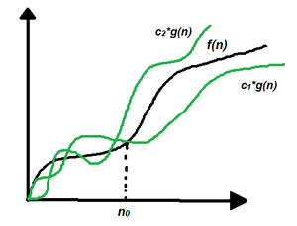
This means that, f(n) = Θ(g(n)), If there are positive constants n0 and c such that, to the right of n0 the f(n) always lies on or above c1*g(n) and below c2*g(n).
Fig 4: Graphical representation of Theta Notation Example
BIG-O NOTATION (O):
- Big-O notation represents the upper bound of the running time of an algorithm. Therefore, it gives the worst-case complexity of an algorithm.
Mathematical Representation of Big-O notation:
Big – O (O) notation specifies the asymptotic upper bound for a function f(n).
For a given function g(n), O(g(n)) is denoted by:
O (g(n)) = {f(n): there exist positive constants c and n0 such that f(n) ≤ c*g(n) for all n ≥ n0}.
This means that, f(n) = O(g(n)), If there are positive constants n0 and c such that, to the right of n0 the f(n) always lies on or below c*g(n).
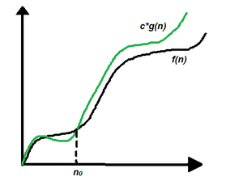
Fig 5: Graphical representation of Big O Notation Example
COMMON TIME COMPLEXITIES
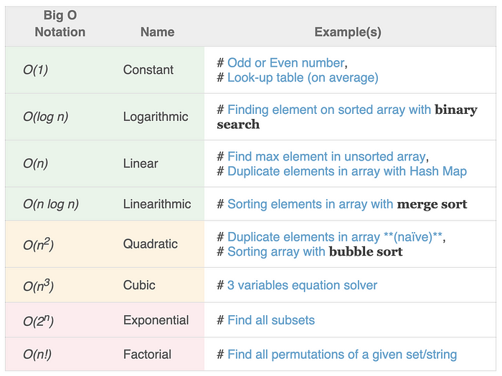
TIME COMPLEXITY – EXAMPLES
1) What is the time complexity of the following code:
a = 0;
for i in range(0, N):
for j in range(N, -1, -1):
a = a + i + j;
Explanation:
The above code runs total no of times
= N + (N – 1) + (N – 2) + … 1 + 0
= N * (N + 1) / 2
= 1/2 * N^2 + 1/2 * N
O(N^2) times.
2)def linear_search(data, value):
for index in range(len(data)):
if value == data[index]:
return index
if __name__ == '__main__':
data = [1, 2, 9, 8, 3, 4, 7, 6, 5]
print(linear_search(data, 7))
Ans: O(n)

Self-Assessment Questions (SAQs)
Q1:
Identify the two types of efficiencies that are important for computer algorithms?
a) Time efficiency and Higher power efficiency
b) Higher power efficiency and Computational efficiency
c) Computational efficiency and Space efficiency
d) Space efficiency and Time Efficiency
Ans: d
Q2:
2.Which one of the following asymptotic notation is used to provide lower bound constraint?
a) X
b) Ω
c) Θ
d) Ο
Ans: b
- Summary
- Introduction about the Algorithm and Data Structure
Calculation of the Time and Space complexity of an algorithm to find out its efficiency
- Asymptotic Notations are of three types
- Big-O Notation (O)
- Theta Notation (Θ)
- Omega Notations (Ω)
- Mathematical representations of the above notations
- Example for each Notation

12 Terminal Questions
1) How is time complexity measured?
Ans: By counting the number of primitive operations performed by the algorithm on a given input size.
2. Which of the following best describes the useful criterion for comparing the efficiency of algorithms?
Ans: Time and Space
3. What does it mean to say that an algorithm X is asymptotically more efficient than Y?
Ans: X will always be a better choice for large inputs
4. Describe the various types of Asymptotic Notations with examples?
There are three different notations: big O, big Theta (Θ), and big Omega (Ω). big-Θ is used when the running time is the same for all cases, Big-O for the worst case running time, and big-Ω for the best case running time.
- Omega Notation (Ω) basically describes the best-case scenario which is opposite to the big O notation.
- The theta notation (Θ) mainly describes the average case scenarios
- , Big O Notation (O) gives the worst-case complexity of an algorithm.
REFERENCES FOR FURTHER LEARNING OF THE SESSION:

Reference Books:
- Data Structures and Algorithm Analysis in PYTHON, 2010, Mark Allen Weiss, Second Edition, Pearson Education.
- Data Structures and Algorithms, A.V.Aho, J.E.Hopcroft, and J.D.Ullman, Pearson Education, First Edition Reprint2003.
- Advanced Guide to Python 3 Programming, John Hunt, 4th Edition, Springer Nature Switzerland AG 2019.
- Python Basics: A Practice Introduction to Python 3, David Amos, Dan Bader, Joanna Jablonski, Fletcher Heisler, 4th edition, Real Python.

Sites and Web links:
  - https://docs.python.org/3/tutorial/datastructures.html
  - https://www.w3schools.com/dsa/dsa_intro.php
  - https://www.geeksforgeeks.org/python-data-structures/
  - https://onlinecourses.nptel.ac.in/noc25_cs59/preview
  - https://www.coursera.org/learn/python-data
  - https://www.codecademy.com/learn/learn-data-structures-and-algorithms-with-python

